1. **Developing Spring Controller and Views:** Request mapping for a path.
2. @Controller inherits from @Component.
3. **Development Process**:
4. Request from browser 🡺 Request Path 🡺 Front Controller 🡺 Controller (With Model)🡺 View Template (JSP, HTML) 🡺 Response
5. 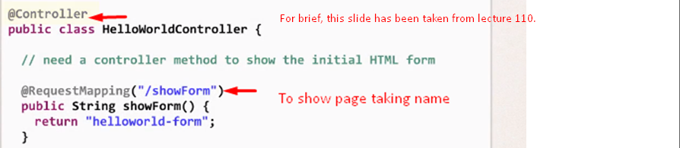
6. 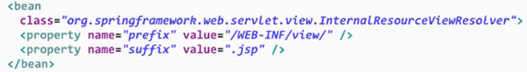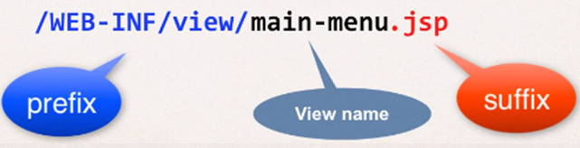
7. In JSP, we can access the request parameters (Parameters from request) using **$**{**param**.parameterName}.
8. **Adding data to Spring Model**: Container for app data. 
9. **lec 118**: War File Deployment to tomcat. Zip file format. Web App Zip File Format.